Identiteitskaart van een voorwerp

Groepsleden: ………………………………………………………………………………………………………………….

Ga in het museum op zoek naar dit voorwerp.

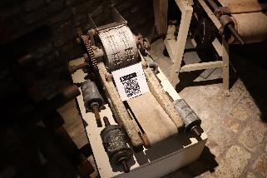

- Bespreek samen en noteer:

a. Wat is de naam van dit voorwerp?

b. Waarvoor wordt het gebruikt?

c. Hoe werkt dit voorwerp?

d. Waarom zou dit voorwerp in het Bakkerijmuseum staan?

- Teken het voorwerp zo goed mogelijk na:

- Beschrijf het voorwerp zodat de anderen het voorwerp kunnen herkennen. (denk aan kleuren, grootte, details, …)

_____________________________________________________________________________

_____________________________________________________________________________

_____________________________________________________________________________

_____________________________________________________________________________

_____________________________________________________________________________

_____________________________________________________________________________

_____________________________________________________________________________

_____________________________________________________________________________

_____________________________________________________________________________

_____________________________________________________________________________

_____________________________________________________________________________

_____________________________________________________________________________

_____________________________________________________________________________

_____________________________________________________________________________

_____________________________________________________________________________

_____________________________________________________________________________

_____________________________________________________________________________

_____________________________________________________________________________

_____________________________________________________________________________

_____________________________________________________________________________

- Welke materialen werden gebruikt? Welke energiebron?

_____________________________________________________________________________

_____________________________________________________________________________

_____________________________________________________________________________

_____________________________________________________________________________

_____________________________________________________________________________

_____________________________________________________________________________

_____________________________________________________________________________

_____________________________________________________________________________

_____________________________________________________________________________

_____________________________________________________________________________

_____________________________________________________________________________

_____________________________________________________________________________

_____________________________________________________________________________

_____________________________________________________________________________

_____________________________________________________________________________

_____________________________________________________________________________

_____________________________________________________________________________

_____________________________________________________________________________

_____________________________________________________________________________

_____________________________________________________________________________

